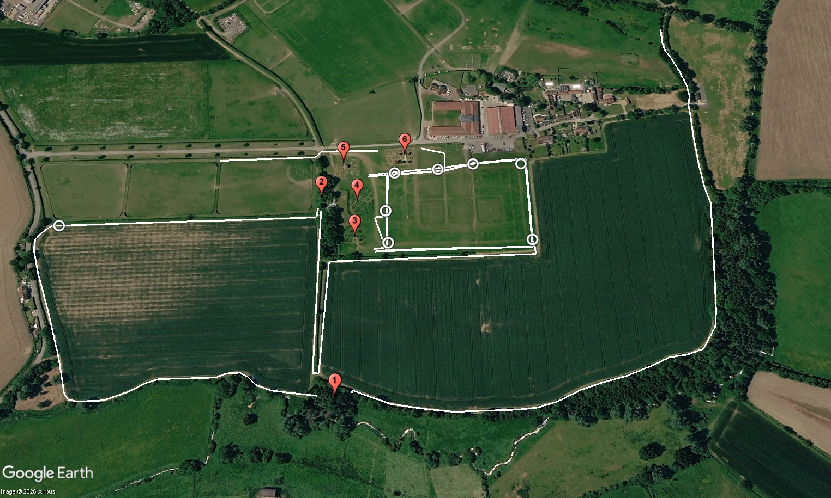
Section B
6650m
6K
5K
4K
3K
2K
1K
CF6,13,20
CF5,12,19,26
CF8,15,22
CF7,14, 21
CF4,11,18,25
CF3,10,17,24
CF2,9,16,23
CF1
End
Start

